Stock Prediction using Mchine Learning

Predict the stock value of Google and Tesla company

# INDEX

|  |  |  |
| --- | --- | --- |
| **SL.**  **No** | **Topics** | **Page No.** |
| 1. | ABSTRACT | 1 |
| 2. | INTRODUCTION | **2** |
| 3. | PREDICTION METHOD | 3 |
| 4. | MACHINE LEARNING | 3 |
| 5. | EXISTING WORK AND PROPOSED WORK | 6 |
| 6. | CODE | 9 |
| 7. | TESLA STOCK PREDICTION | 11 |
| 8. | CONCLUSION | 14 |
| 9. | REFERENCE | 14 |

**Abstract:-**

Accurate prediction of stock prices plays an increasingly prominent role inthestock market where returns and risks fluctuate wildly, and both financial institutionsand regulatory authorities have paid sufficient attention to it. As a method of assetallocation, stocks have always been favored by investors because of their high returns. The research on stock price prediction has never stopped. In the early days, manyeconomists tried to predict stock prices. Later, with the in-depth researchofmathematical theory and the vigorous development of computer technology, peoplehave found that the establishment of mathematical models can be very good, suchastime series model, because its model is relatively simple and the forecasting effect isbetter.Stock market prediction using Machine learning will help to analysis the future value of company stock using Linear Regression and LSTM in Python. This article introduces the theoretical knowledge of time series model and LSTM neural network, and select real stocks in the stock market, perform modeling analysis and predict stock prices, and then use the rootmean square error to compare the prediction results of several models.

**Introduction:-**

As a high-risk and high-return market, the stock market has always been closelywatched by investorsand stock forecasting has always beenaresearch topic of great concern to researchers. In addition, the stock market is animportant part of my country's financial market, it reflects the operation of thenational economy, and the operation of the stock market has an important impact onthe operation of the national economy. Although the issue of predictability of stockshas always been controversial, the study of stock forecasts still helps us understandthe laws of some market changes and development.

Due to the high profit of the stock market, it is one of the most popular investments. Peopleinvestigated for methods and tools that would increase their gains while minimizing the risk, as the level of trading and investing grew. Two stock exchanges namely- the National Stock Exchange (NSE) and the Bombay Stock Exchange (BSE), which are the most of the trading in Indian Stock Market takes place. Sensex and Nifty are the two prominent Indian Market Indexes. Since the prices in the stock market are dynamic, the stock market prediction is complicated. From gradually the very past years some forecasting models are developed for this kind of purpose and they had been applied to money market prediction. Generally, this classification is done by:

1) Time series analysis

2) Fundamental analysis

3) Technical analysis

Importance of Stock Market:-

* It helps company to raise capital.
* It helps create personal Wealth.
* Serves as an indicator of the State of the economy.
* It helps to increase Investment.

Stock Market Prediction:-

Stock market prediction is the act of trying the determine the future value of the company stock or other financial instrument traded on an exchange. The successful prediction of Stock’s future price could yield significant profit. The efficient-market hypothesis suggests that Stock prices reflect all currently available information and any price changes that are not based on newly revealed information.

**Prediction Method:-**

Prediction methodology fall into three broad categories which can overlap. They are:

1. Fundamental Analysis
2. Technical Analysis
3. Technological Method that is Machine Learning

This report enlight that the stock market prediction using machine learning which further cover the concept of linear regression and LSTM.

**Machine learning:-**

With the advent of the digital computer, Stock market prediction has sins move into the Technological realm. The most prominent technique involves the use of Long Short Term Memory(LSTM) and Linear Regression. Long Short Term Memory is a Artificial Neural Network(ANN) used in the field of Artificial Inteligence and Deep Learning.

Linear Regression:-

Linear regression is one of the easiest and most popular Machine Learning algorithms. It is a statistical method that is used for predictive analysis. Linear regression makes predictions for continuous/real or numeric variables such as sales, salary, age, product price, etc. Linear regression algorithm shows a linear relationship between a dependent (y) and one or more independent (y) variables, hence called as linear regression. Since linear regression shows the linear relationship, which means it finds how the value of the dependent variable is changing according to the value of the independent variable. The linear regression model provides a sloped straight line representing the relationship 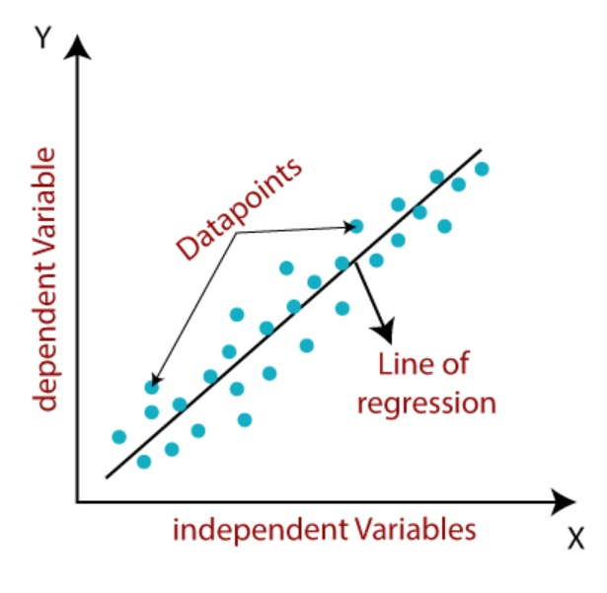between the variables. Consider the below image:

It can be used in to predict the total revenue of a company or total unit to be sold of a certain product. It can be also used of predict the weather prediction and stock prediction also.

Long Short Term Memory:-

With the development of deep learning neural networks, people have graduallyrealized that neural networks can be used as a new predictive method: First, neural networks have low data requirements and do not require strict assumptions; at thesame time, it can also choose non-linear activation. The function converts the linear mapping into a nonlinear mapping, and then through the processing of the hiddenlayer, it further enhances its ability to process nonlinear data. However, the generalneural network does not make much use of the time sequence. Each network layer isperforming calculations at the same time,ignoring the time sequence of the data. Therefore, the Recurrent Neural Network (RNN) was born. The connection of the 4 same layer completes the task of extracting data sequence. Of course, RNNalsohasits own shortcomings. LSTM are a type of RNN for earning long term dependency. It is commonly used for predicting on 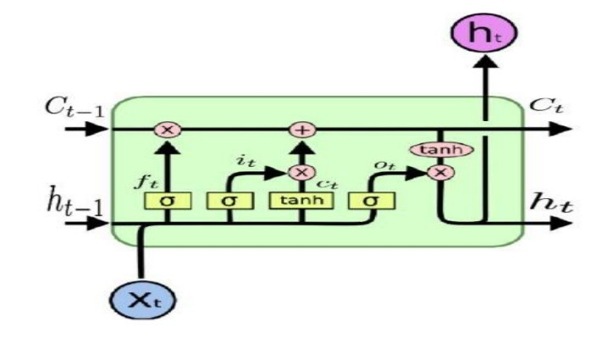the basis of time sharing data.

Artificial Neural Network:-

The term "Artificial Neural Network" is derived from Biological neural networks that develop the structure of a human brain. Similar to the human brain that has neurons interconnected to one another, artificial neural networks also have neurons that are interconnected to one another in various layers of the networks. These neurons are known as nodes.

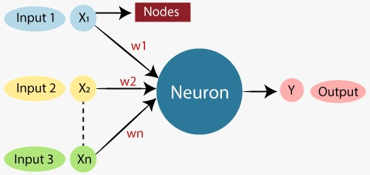

**Existing Work and Proposed Work:-**

Stock Price Prediction by Machine Learning present to estimate the stock future value and machine learning technique like LSTM for existing work. This machine-learning algorithm is to perform the best predicting result of the stock future price. LSTM is capable to catching the modifications in the behavior of the stock price for the indicated period in this proposed system.

Propose a machine learning-based normalization for stock price prediction. The dataset utilized for analysis was selected from Simplilearn. It consists of approximately 1260 for of the required Stock price and other relevant data. The data reflected the stock price at some time intervals for every day of the year. It contains various data like date, open price, close price, low price, high price and volume. Here, the data for only one company was considered. All the data was available in a file of CSV format which was first read and transformed into a data frame using the Pandas library in Python. The normalization of the data was performed through the sklearn library in Python.

This paper focuses on two architecture Regression-based Model and LSTM. The Regression-based Model is employed for predicting unbroken values through some given autonomous values Regression uses a given linear function for predicting continuous values of the most important amongst them and made the predictions using these. LSTM architecture is able to identify the changes in trends which show evident from the result. LSTM is identified as the best model for the proposed methodology. This shows that the proposed system is capable of identifying some interrelation within the data. In the stock market, there may not always follow the same cycle or may not always be in a regular pattern for the changes that are occurred. The period of the existence will differ and the existence of the trend is based on the companies and the sectors. For investors, this type of analysis of trends and cycles will obtain more profit. We must use networks like LSTM as they rely on the current information to analyze various information.

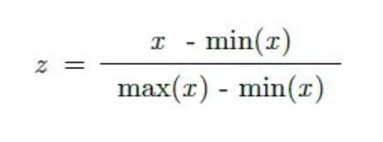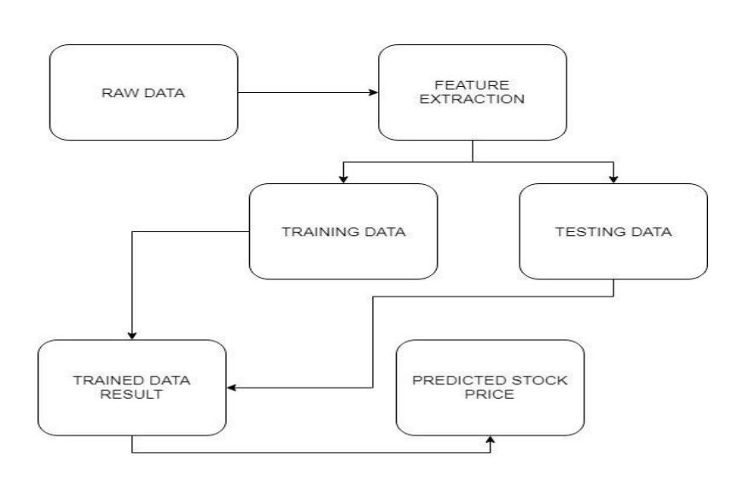The first step involves preprocessing the given training data. This includes the following three steps: 1. Replacing missing data The data points missing in the training data were replaced with the mean of the data in the respective column. 2. Splitting the data The training data was split into input and output data. 3. Normalizing the input data Finally, the input data (represented by X) was normalized using the MinMaxScaler Method. The formula used in this method is given below:

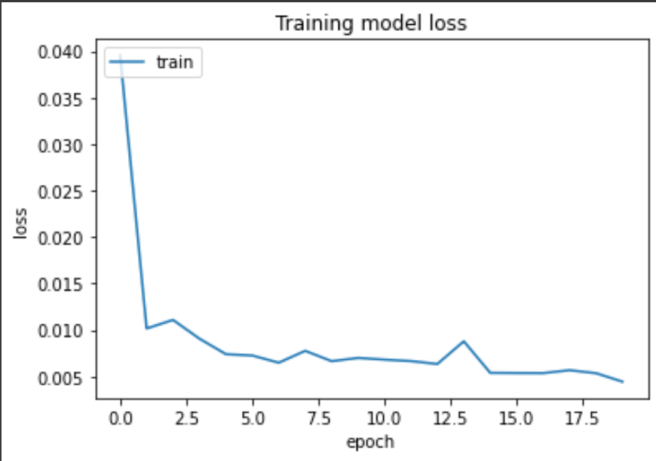The different approaches adopted in this project utilize regression using Neural Networks to make future predictions of stock returns.After splitting and normalizing the data, the above-mentioned Regression model was trained onit. This model proved to be overfitting and the loss was 0%. Then the Sequential Model was tried. Initially, itgave a large Mean Square Error. On trying deeper topology, different number of epochs, and varied batch sizesthis error, as well as loss, was reduced.

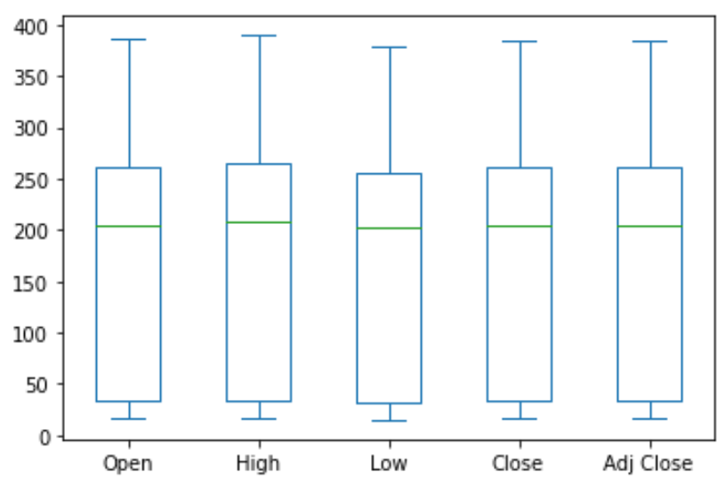

**CODE:-**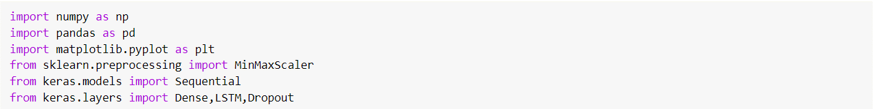







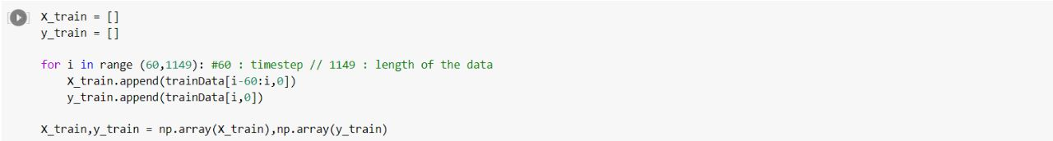



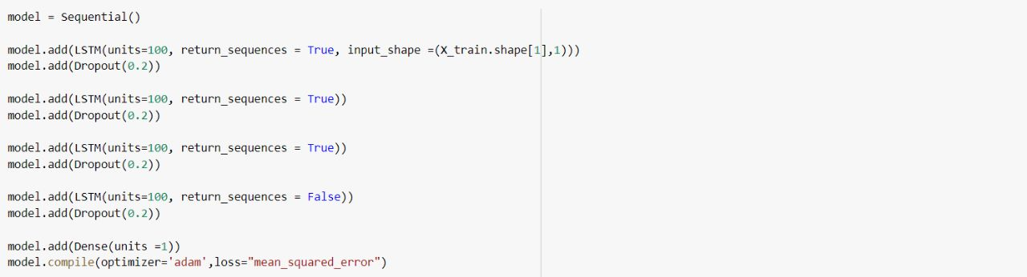

C:\Users\DELL\AppData\Local\Packages\5319275A.WhatsAppDesktop_cv1g1gvanyjgm\TempState\62C2FBD641A48005A0F7487810055E81\WhatsApp Image 2022-11-14 at 19.31.57.jpg

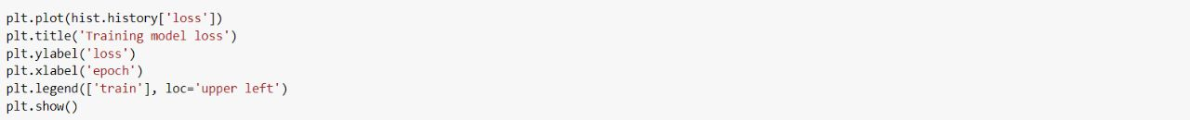

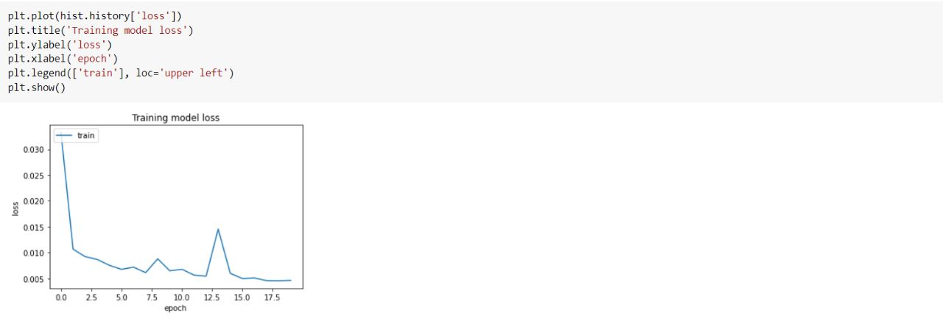

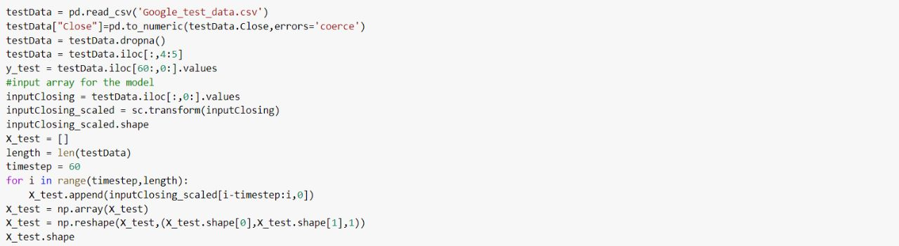

C:\Users\DELL\AppData\Local\Packages\5319275A.WhatsAppDesktop_cv1g1gvanyjgm\TempState\69910D6133A08650FA5DF9A7964ED439\WhatsApp Image 2022-11-14 at 19.41.14.jpg

C:\Users\DELL\AppData\Local\Packages\5319275A.WhatsAppDesktop_cv1g1gvanyjgm\TempState\4CD4A3C3819E109EE81470176015728A\WhatsApp Image 2022-11-14 at 19.39.44.jpg

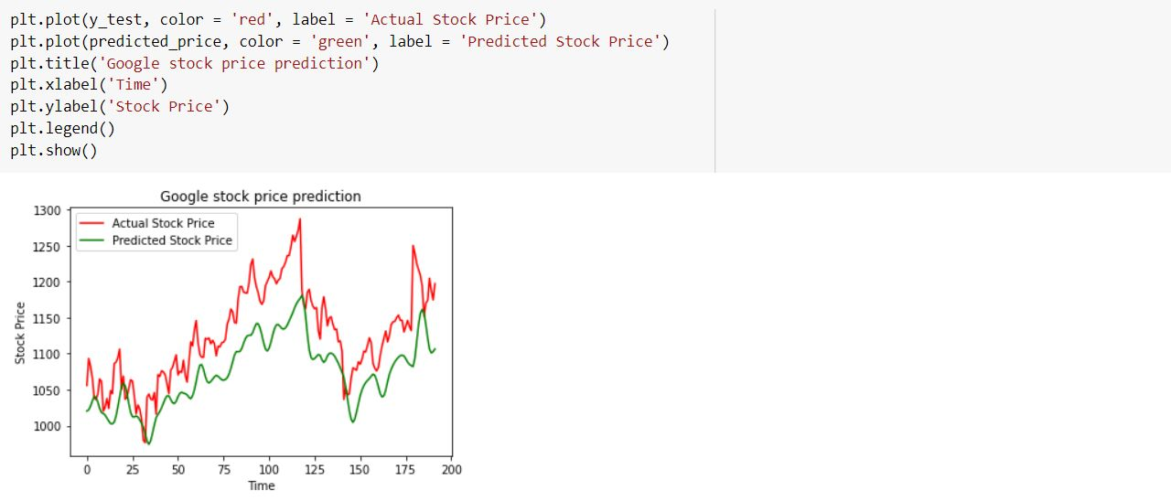

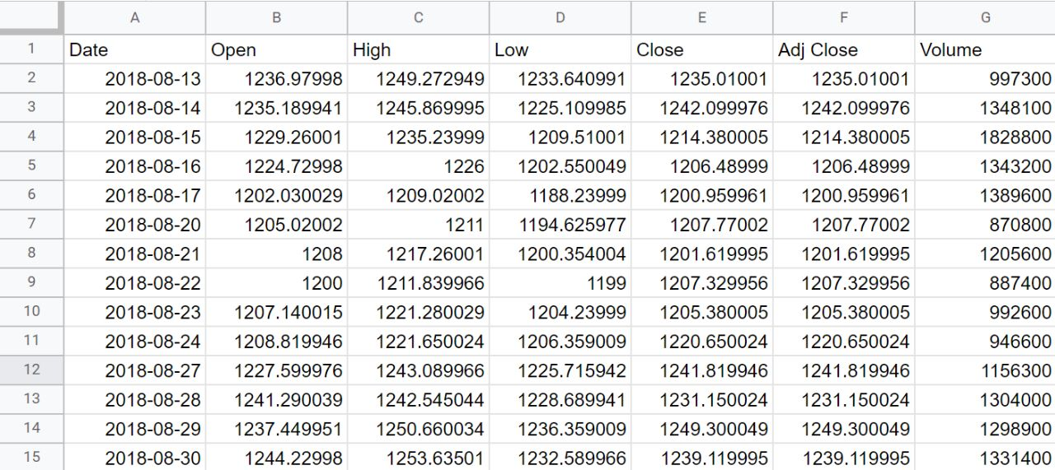

GOOGLE CSV

TESLA STOCK PREDICTION

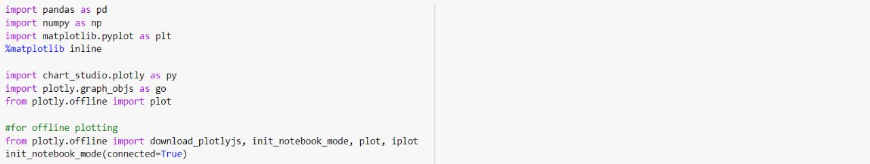

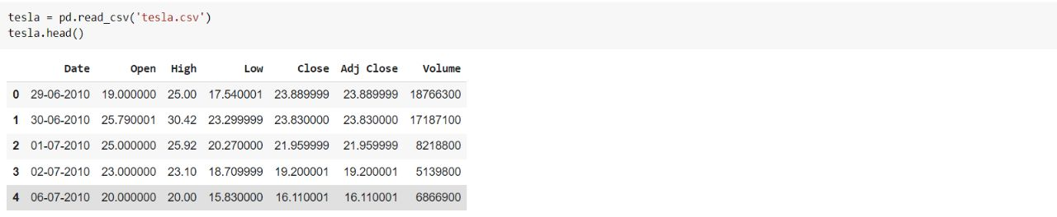

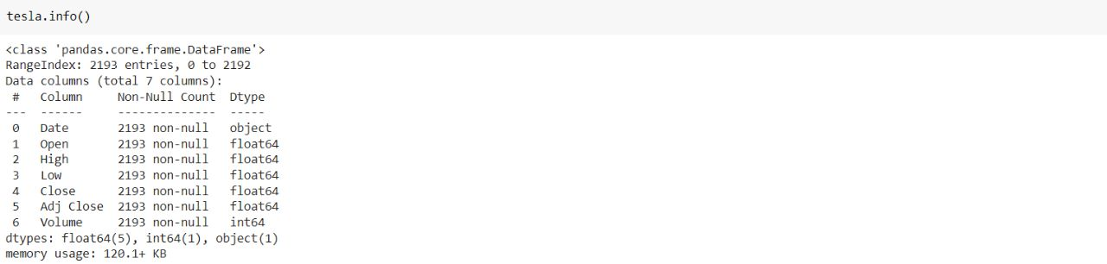

C:\Users\DELL\AppData\Local\Packages\5319275A.WhatsAppDesktop_cv1g1gvanyjgm\TempState\6251EC3A609CFD5CA986BD9972D20B7A\WhatsApp Image 2022-11-14 at 20.01.46.jpg



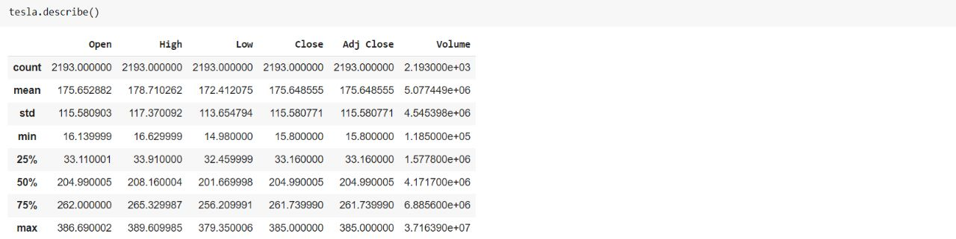

C:\Users\DELL\AppData\Local\Packages\5319275A.WhatsAppDesktop_cv1g1gvanyjgm\TempState\9FB0B4D60BFEF7BF4382BF8FA7EA945E\WhatsApp Image 2022-11-14 at 20.07.08.jpg

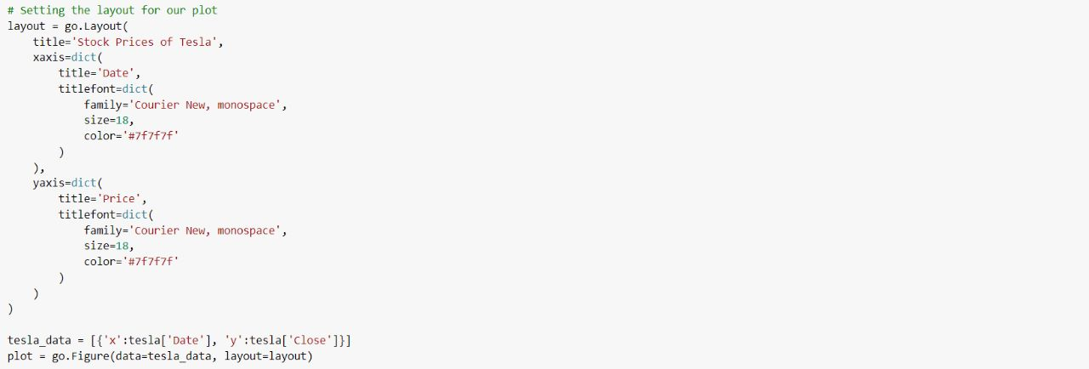

C:\Users\DELL\AppData\Local\Packages\5319275A.WhatsAppDesktop_cv1g1gvanyjgm\TempState\0E639653C10D1353DFBC8E4A14DF280E\WhatsApp Image 2022-11-14 at 20.09.44.jpg

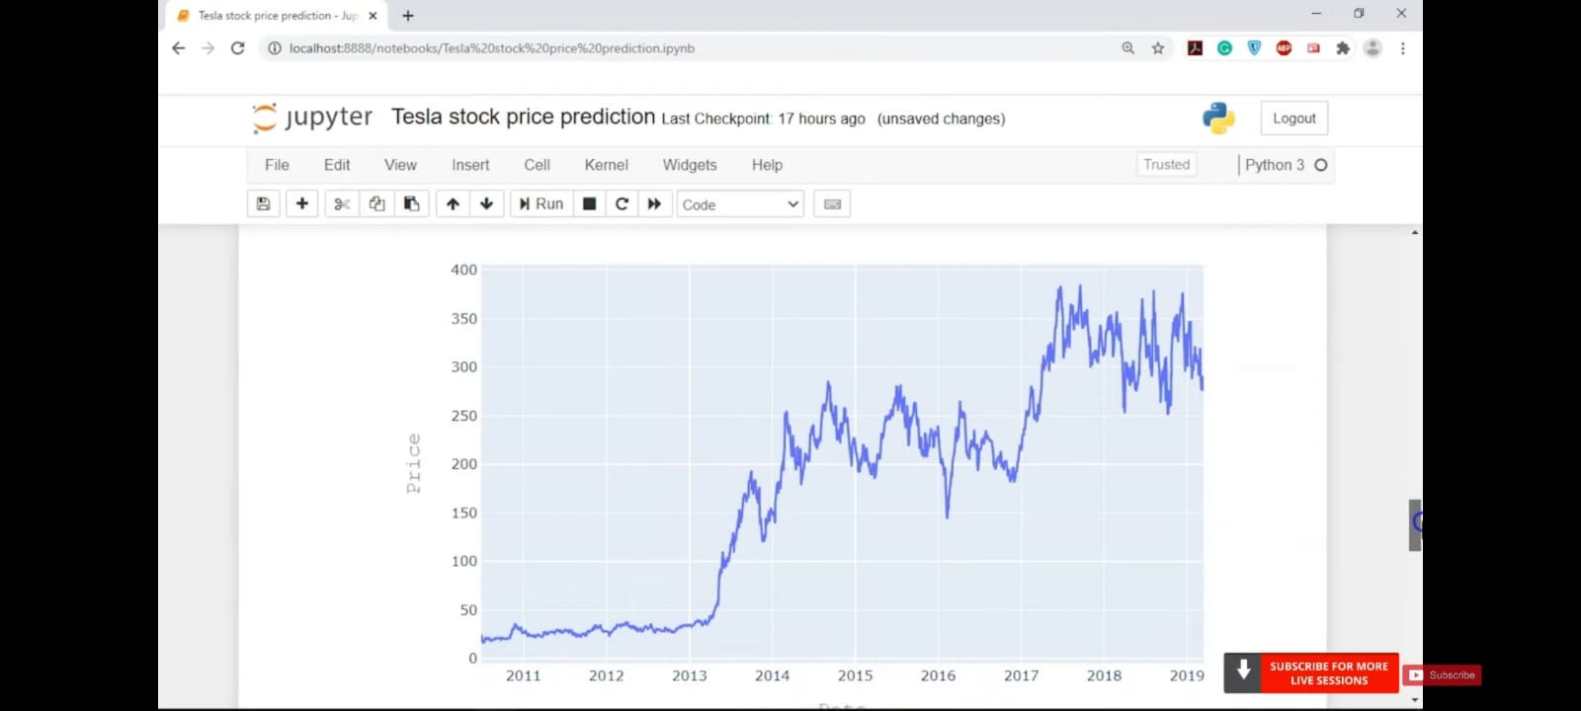

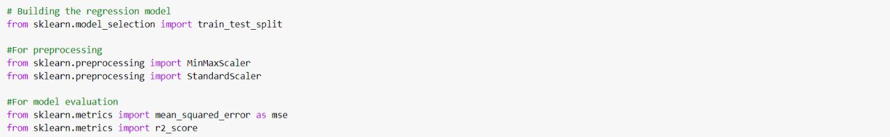



C:\Users\DELL\AppData\Local\Packages\5319275A.WhatsAppDesktop_cv1g1gvanyjgm\TempState\8292195F4BD46E2BA9790F674A4C906F\WhatsApp Image 2022-11-14 at 20.16.26.jpg

C:\Users\DELL\AppData\Local\Packages\5319275A.WhatsAppDesktop_cv1g1gvanyjgm\TempState\777B02102EECC65C3778E53776B416D6\WhatsApp Image 2022-11-14 at 20.16.33.jpg



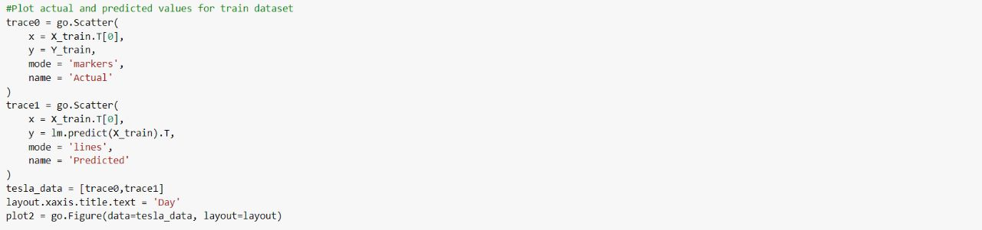

C:\Users\DELL\AppData\Local\Packages\5319275A.WhatsAppDesktop_cv1g1gvanyjgm\TempState\BBACBBC9DEB01FF97BFA8F71DA0171E0\WhatsApp Image 2022-11-14 at 20.16.49.jpg

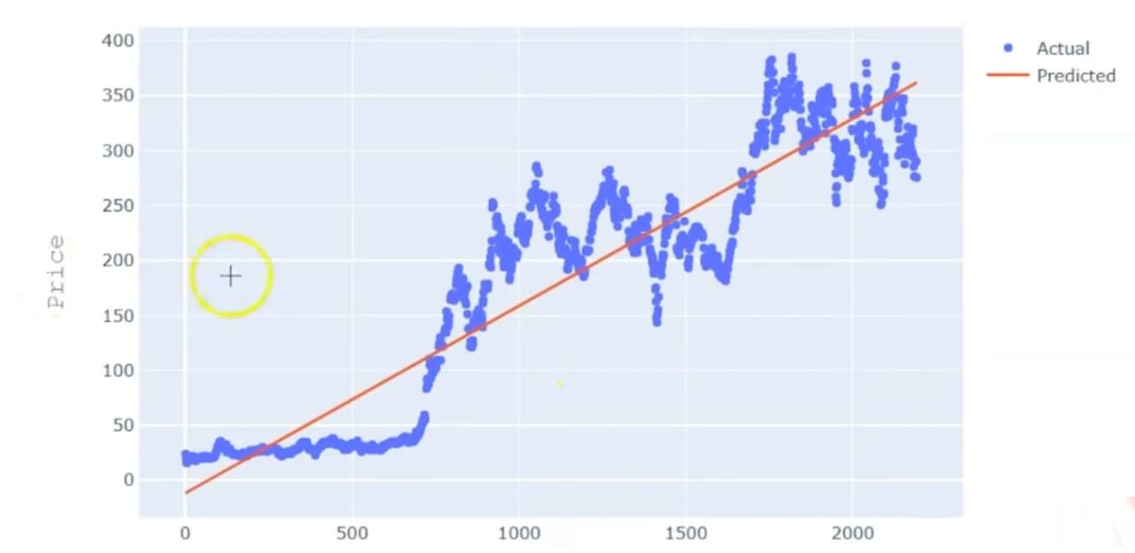

TESLA CSV

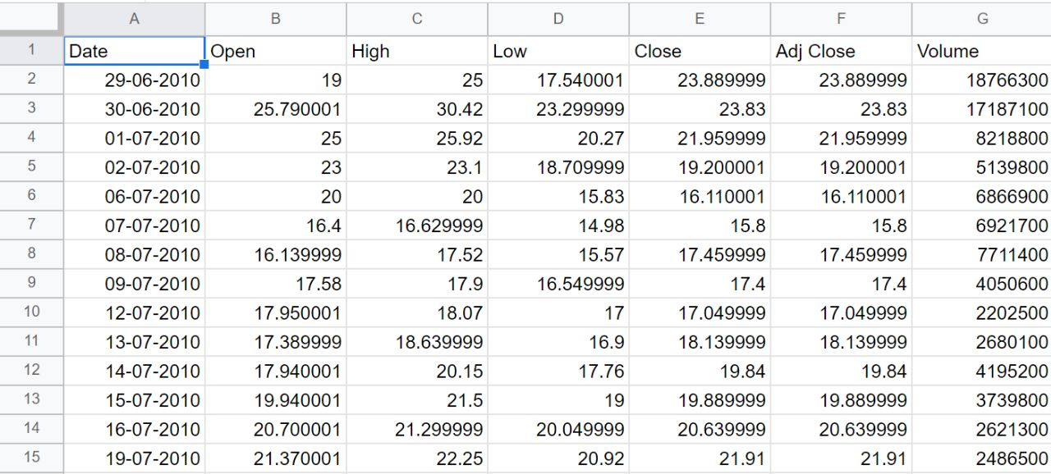

**Conclusion:-**

In report, we will compare a machine learning models like LSTM model, the Linear Regression model and also the hybrid approach of LSTM + Linear regression model. We have a tendency to train the model using the data of NSE listed companies to predict the stock future value. This is shows the proposed method is capable to distinctive around interrelation with the data. Also, it is evident from the results that, Hybrid approach of LSTM + Linear Regression model is capable to identify the changes in trends. For the projected method the Hybrid approach of LSTM+ Linear Regression is known as the best model.

**References:-**

1. <https://www.simplilearn.com/tutorials/machine-learning-tutorial/stock-price-prediction-using-machine-learning>
2. <https://data-flair.training/blogs/stock-price-prediction-machine-learning-project-in-python/>
3. “Stock price prediction using LSTM, RNN and CNN-sliding window model – IEEEConference Publication.” https://ieeexplore.ieee.org/document/8126078 (accessed Dec.27, 2019).
4. J. Jagwani, M. Gupta, H. Sachdeva, and A. Singhal, “Stock Price Forecasting Using Datafrom Yahoo Finance and Analysing Seasonal and Nonseasonal Trend,” in 2018 SecondInternational Conference on Intelligent Computing and Control Systems (ICICCS),Madurai, India, Jun. 2018, pp. 462–467, doi: 10.1109/ICCONS.2018.8663035.